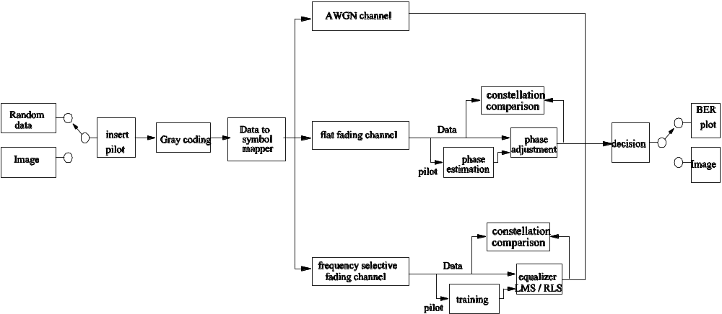

Figure 1: flow chart of Matlab simulation

Figure 1 shows the flow chart of our model used in the project. Our simulation supports two kinds of source data, either the randomly produced data or an image file. While random data is ideal to test the channel impact to the BER performance and signal constellation, image file give us an intuitive impression and comparison for different channels.

After the source data is produced, the pilot data is inserted into head of source data in each coherence time. It is used to estimate the random phase shift of the fading channel and train the decision to adjust the received signal with phase recover. User may set any percentage of the pilot data length to the total data length (pilot data plus source data) in our model. In our simulation, we set the pilot data as 8% of the total data length.

Then, user may choose to use gray coding or not in the simulation. After gray coding, data is mapped from binary data to complex data, and each output datum represents a point in the constellation diagram. In our model, we use phase shift keying (PSK) modulation to modulate the data source, and user may choose arbitrary M-ary PSK to modulate the signal. In our simulation, we test the QPSK modulation.

In our simulation, we simulate three different channels: AWGN channel, Rayleigh flat slow fading channel, and Rayleigh frequency selective slow fading channel. AWGN channel is very straightforward by just add a white Gaussian noise into signal to meet specified SNR. We simulate both flat fading and frequency selective fading channels by Clarke and Gans fading model (Rappaport textbook). User may set different velocity to get different coherence time for both these two fading channels.

In the receiver side, we need channel estimation for flat fading channel or adaptive equalizer for frequency selective fading channel. Since we use PSK modulation in our model, the channel phase information in each coherence time need to be estimated, and the weight of each tap in the equalizer need to be trained by pilot data. Then, source data are adjusted by estimated phase for flat fading channel or equalized by trained equalizer for frequency selective fading channel. The received signal constellations of both with and without adjustment are dynamically showed in the simulation. User may choose to plot constellation or not in the program, and if they choose to plot constellation, they may also set the SNR for the constellation.

Decision device decide each adjusted symbol, correspondent to each point in constellation, to a binary datum. At last, we get the bit error rate by compare source data and received binary data. For image data, the binary data is converted back to image data and displayed.

